Creating a collage using GIMP

1. Create a folder on your desktop or other location and name it GIMP

2. Get the images off of the USB key or get eight or more images intended for this project from the internet and place them in the GIMP folder.

3. Open GIMP

4. When the following window appears, close the tip menu.

5. The following windows are important to create your masterpieces: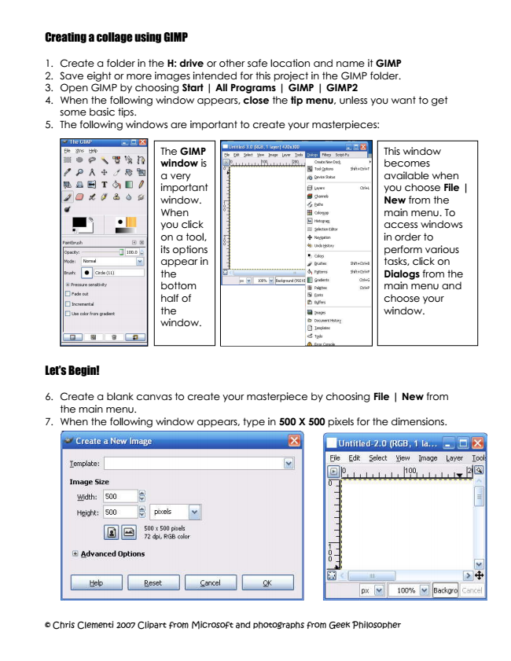

The GIMP window is a very important window. When you click on a tool, its options appear in the bottom half of the window.

Let’s Begin!

6. Create a blank canvas to create your masterpiece by choosing File | New from the main menu.



7. When the following window appears, type in 500 X 500 pixels for the dimensions.

This window becomes available when you choose File | New from the main menu. To access windows in order to perform various tasks, click on Dialogs from the main menu and choose your window.

8. Save the new window by choosing File | Save As from the main menu.

9. When the following window appears, type in collage in the Name section as shown below.

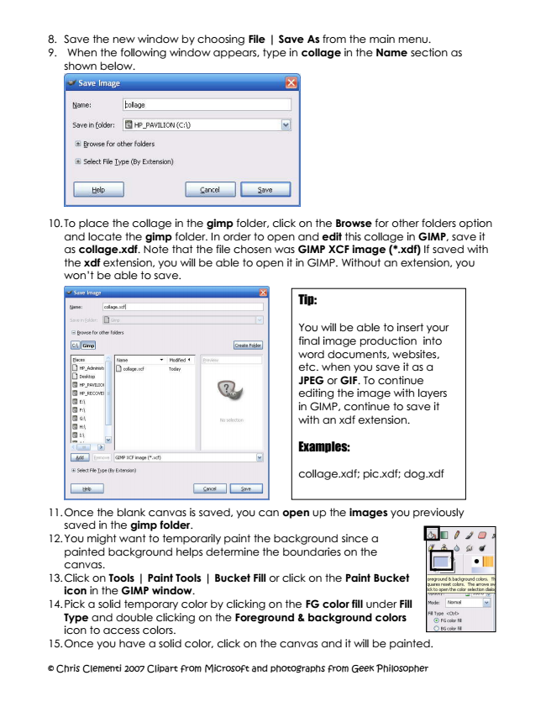



10. To place the collage in the gimp folder, click on the Browse for other folders option

and locate the gimp folder. In order to open and edit this collage in GIMP, save it as collage.xdf. Note that the file chosen was GIMP XCF image (*.xdf) If saved with the xdf extension, you will be able to open it in GIMP. Without an extension, you won’t be able to save.

Tip:

You will be able to insert your final image production into word documents, websites, etc. when you save it as a JPEG or GIF. To continue editing the image with layers in GIMP, continue to save it with an xdf extension.



Examples:

collage.xdf; pic.xdf; dog.xdf

11. Once the blank canvas is saved, you can open up the images you previously saved in the gimp folder.

12. You might want to temporarily paint the background since a painted background helps determine the boundaries on the canvas.

13. Click on Tools | Paint Tools | Bucket Fill or click on the Paint Bucket icon in the GIMP window.

14. Pick a solid temporary color by clicking on the FG color fill under Fill Type and double clicking on the Foreground & background colors icon to access colors.

15. Once you have a solid color, click on the canvas and it will be painted.

Let’s put images on the collage!

16. To open images, choose File | Open from the canvas menu.

Navigate to the gimp folder and select the images. To select more than one image, hold down the control key. Once the images are selected, click on the Open button.

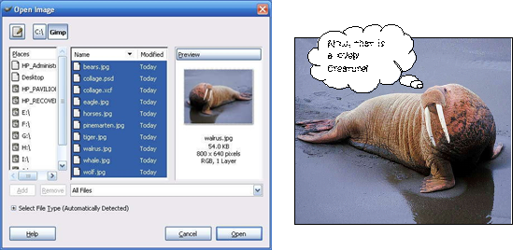

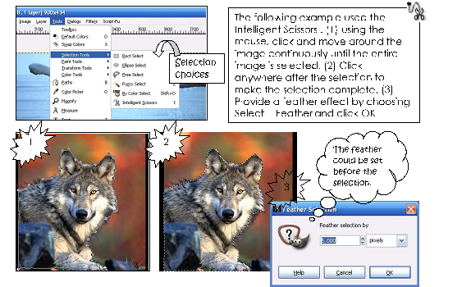

17. To select part of the image in order to copy it and paste it on the collage, choose

**Tools | Selection Tools | (Select from the tool that will best suit your needs )**

The following example used the Intelligent Scissors. (1) using the mouse, click and move around the image continuously until the entire image is selected. (2) Click anywhere after the selection to make the selection complete. (3) Provide a feather effect by choosing Select | Feather and click OK.

If the selection doesn’t occur, select the layer in the Layer’s window and hit the Enter key on the keyboard. If the Layer’s window isn’t showing, choose Dialogue | Layers in the menu of the image you are selecting.

18. Once the selection is made, you can choose Edit | Copy in order to copy the selection.

19. Open or access the collage canvas and choose Edit | Paste from the menu.

20. Since the image pasted is taking up the majority of the collage canvas, it needs to be resized to roughly 200 pixels wide. See number 19.

21. Choose Layer | Scale Layer from the menu. Click on the drop down arrow of the Width option and set it to roughly 200 pixels. The Height should adjust accordingly, so don’t worry about adjusting it if it changes as you adjust the Width.

22. The following is an example of before and after resizing the layer.

**Before After**

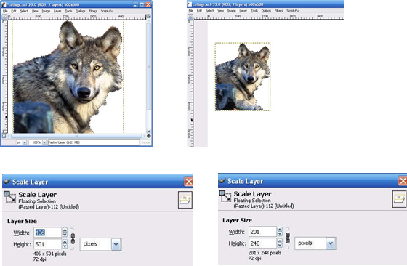

23. To move the image, make sure you are on the correct layer. Select the Move tool from the GIMP window and move your image.

24. Continue getting the other images by using the selection tool of your choice. You can click on the selection tools in the Tools window (known as The GIMP) or choose Tools | Selection Tools | (selection)

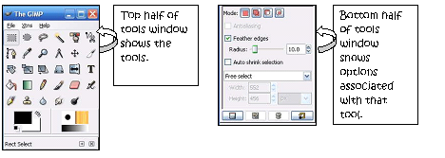

25. Before copying and pasting a selection, make sure your Layer’s Window is showing. If the Layers window isn’t showing, choose Dialogue | Layers from the menu of the collage.

1. The window will look something like the following example.
2. When you choose Edit | Paste, the Layers window will have added a layer that says, “Floating Selection (Pasted Layer)
3. When you hit the Enter Key on the keyboard a couple of times while on the Floating Layer, it will show the Walrus.
4. Rename the layer, by double clicking on the layer and typing in an appropriate name.

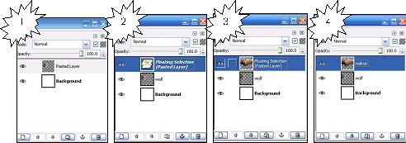

26. You can resize the recently copied image by repeating steps 18 and 19. The width

and height will vary depending on the image being resized. In the walrus example, the width was set to roughly 400 pixels wide. It all depends on what effects you want.

**Examples of different selection tools:** Tip, set the feather edges before using the following selection tools. This becomes available in the GIMP window when you click on the selection tool. Setting the feather gives softer edges around the selected image. Drag the selection tools around the part of the image you want to copy. Once it is selected, choose Edit | Copy from the main menu or Ctrl + C

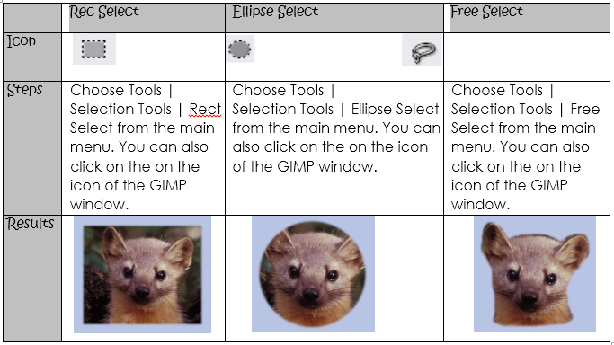

27. The following steps show how to use the Gradient tool to create a background. (1) Make sure you have selected the background layer. If the Layer’s window isn’t showing, choose Dialog | Layers from the menu. (2) Select the Gradient tool in the Tools Window (3) Click on the gradient options to get a variety of choices. (4) Change the shape of the gradient if you choose.

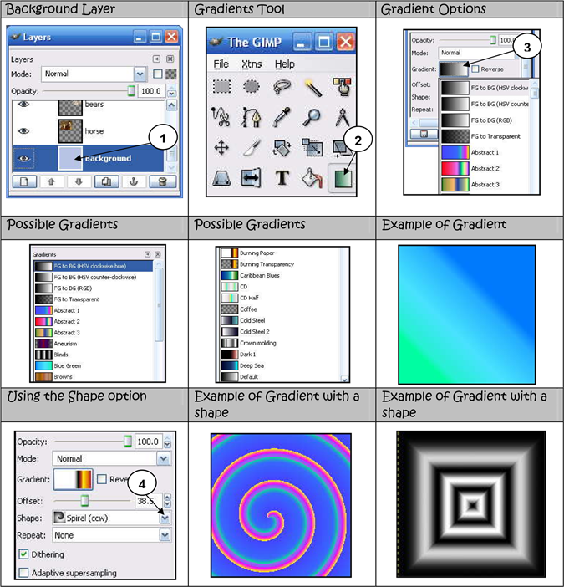

Adding a Background with Paint Bucket Fill

28. The following steps show how to use the Paint Bucket tool to create a background.

1. Make sure you have selected the background layer. If the Layer’s window isn’t showing, choose Dialog | Layers from the menu.
2. Select the Paint Bucket tool in the GIMP Window
3. Click on the Foreground & Background options in the GIMP window to get a solid color or
4. Click on the Pattern fill option to get a variety of patterns to fill the background. The bubble of the Pattern fill needs to be selected or you won’t be able to access patterns.

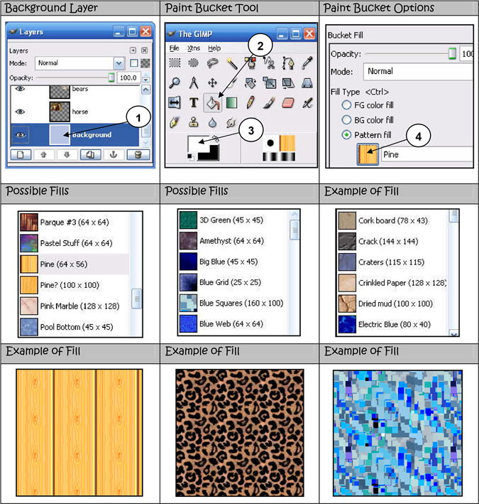

Adding Text

29. To add text, (1) select the Text tool in the GIMP window. (2) Change the Font Style,

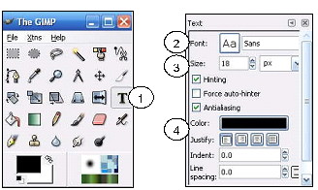

30. Click down on your canvas and

1. a window will appear for you to type in the text.
2. As you type in the window, you will be able to see if you like the font size, style and color.
3. You can make changes before accepting the text, by changing the color, font style and font size in the GIMP window.

31. If the text is beneath other layers, simply drag it and drop it on top of the other layers in the layers window.

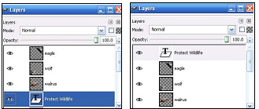

32. If you want to apply unique effects to the text, make sure you are on the Text Layer

that you want to modify. Click on the drop down arrow of the Mode option in the Layer’s window and experiment with your choices. The default is Normal.

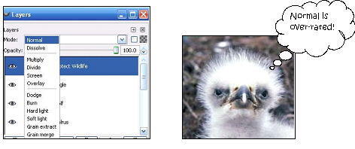

33. If you want to apply filter effects to the text, make sure you are on the Text Layer

that you want to modify. Right click on the text of your collage and select Filters.

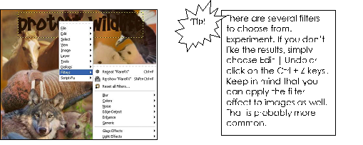

34. The following example used Filter | Distort | Wind. It is important to experiment with

the options in these windows to get the desired results.

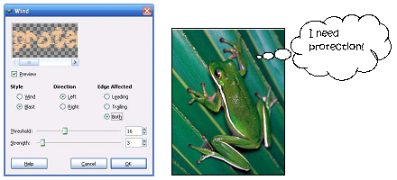

Fading images by changing the opacity of a layer.

35. Choose a layer to fade. In this case, the Layer’s window was accessed and the

tiger layer was selected.

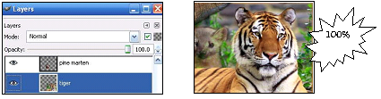

36. Locate Opacity and move the leverage until you are satisfied with the results of the

transformation. In the example, the opacity was changed to 50%.

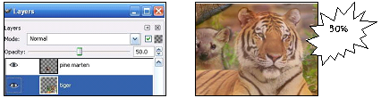

More on Filter Effects

37. Click on the layer you want to apply a filter effect.

38. Right click on the image on the collage window and choose Filter | (Choose from a wide range of choices).

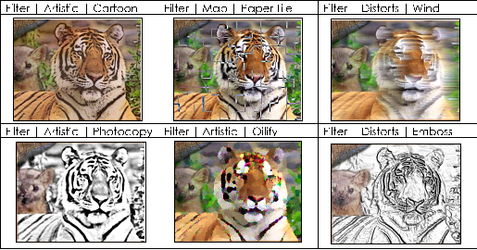

Saving Image for other applications, such as a website

39. Make sure you save your collage with the layers before preparing it for other applications.

40. Choose File | Save As from the collage window.

41. Locate the folder you want to save the image

42. Select the File Type. In this case, since it is a photo intended for a website or word document, choose JPEG image which will add the .jpg extension to your collage. Clipart is usually saved as a GIF

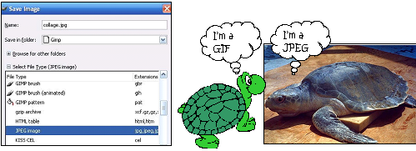

43. If the following window pops up, choose Export, since your image needs to be flattened.

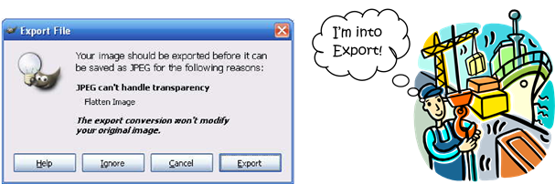

44. When the following window pops up, unless you understand the specifications of quality, leave the default settings and choose OK.

